Abigeil Zenelaj
Activity diagram
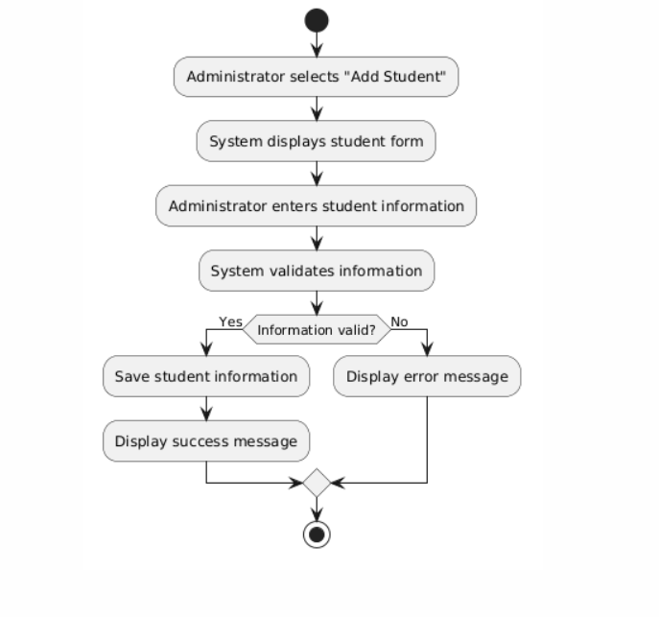
Use case
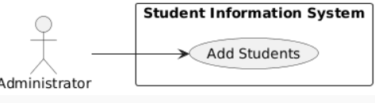
Use Case table
Field | Description
Use Case Name | Add Students
Primary Actor | Administrator
Goal | Add a new student to the system
Preconditions | Admin is logged in
Postconditions | Student data is saved
Main Flow | Open form → Enter data → Validate → Save
Alternative Flow | Error shown if data is invalid

Sequence diagram
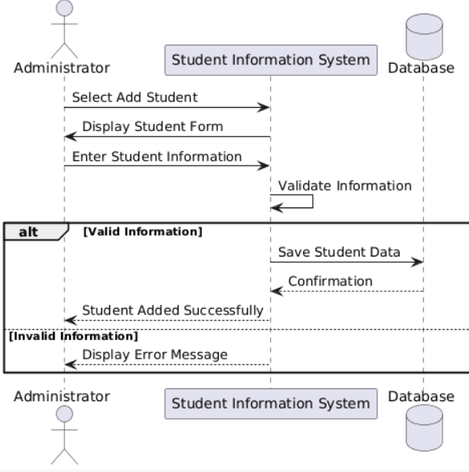
Communcation diagram
